

Database Systems
( Course Code: CSC270 )

Name: Muhammad Abdullah
Roll No # FA24-BSE-042
Instructor Name: Dr Rubina Adnan

Lab - 3
Lab Task 1:
Write a SQL statement that retrieves the last name and department number for employee number 176.
Output:
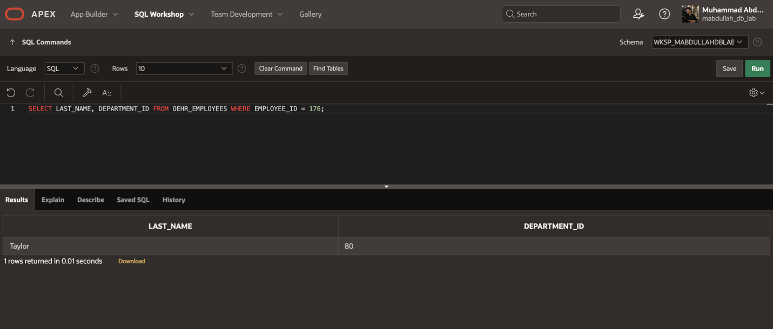
Lab Task 2:
Write a SQL statement that retrieves the last name and salary for any employee whose salary is not in the range of 5,000 to 12,000.
Output:

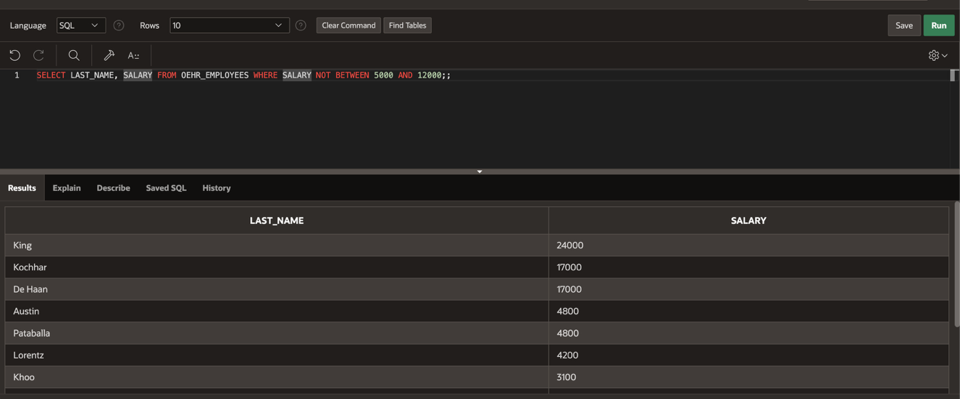

Lab Task 3:
Write a SQL statement that retrieves the last name, job ID, and hire date for employees with the last names of Matos or Taylor. Sort the resultant rows in ascending order by the hire date.
Output:
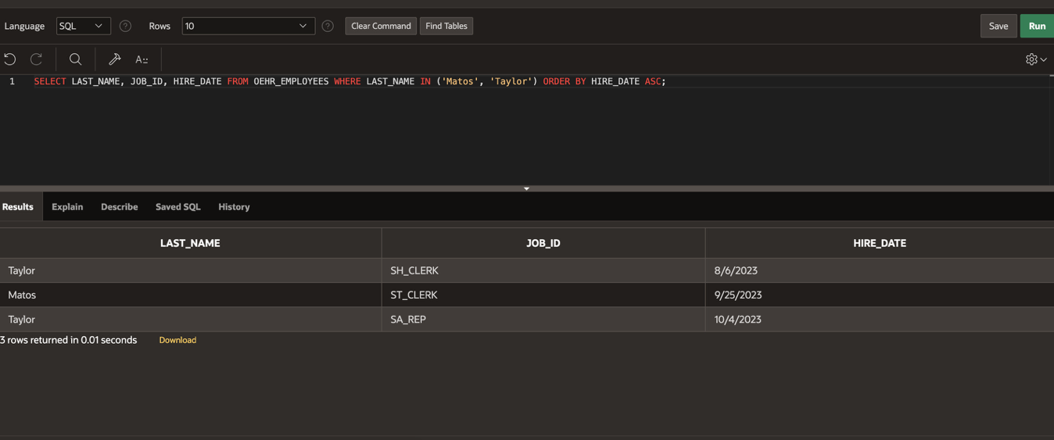
Lab Task 4:
Write a SQL statement that retrieves the last name and department ID of all employees in departments 20 or 50 in ascending alphabetical order by name.
Output:
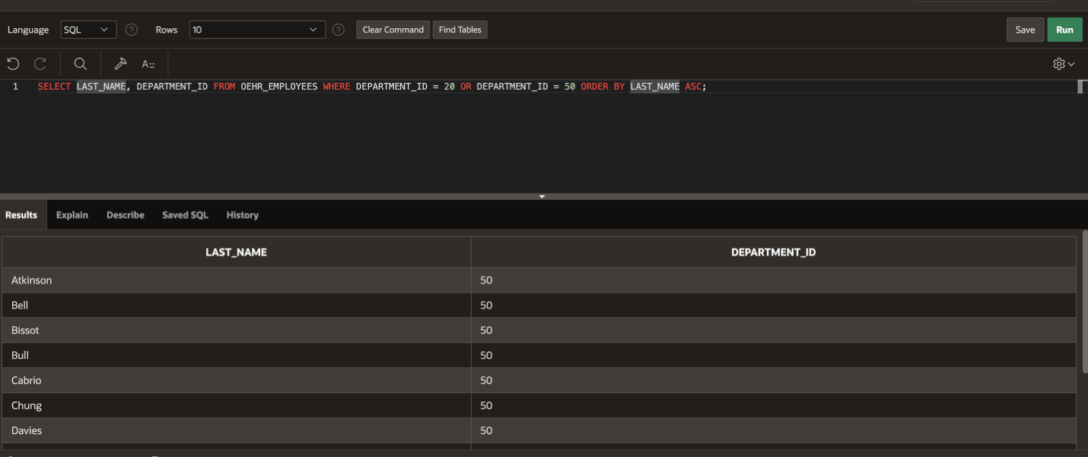

Lab Task 5:
Write a SQL statement that retrieves the last name and job title of all employees whose department ID is unknown.
Output:
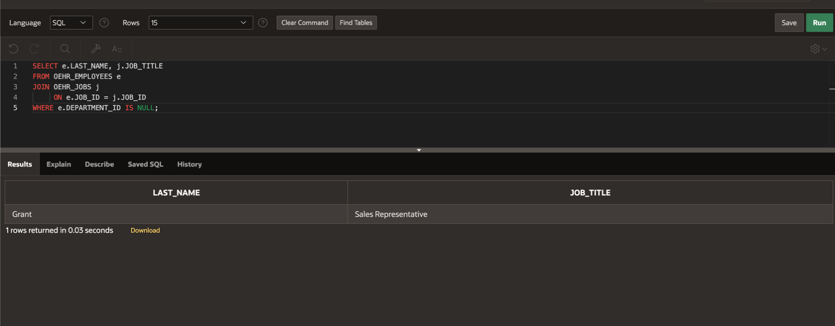

Lab Task 6:
Write a SQL statement that retrieves the last name, salary, and commission of all employees who earn commissions (i.e., the commission_pct is not NULL). Sort the resultant rows in descending order of salary and then commissions. Use the salary column’s numeric position in the ORDER BY clause.
Output:
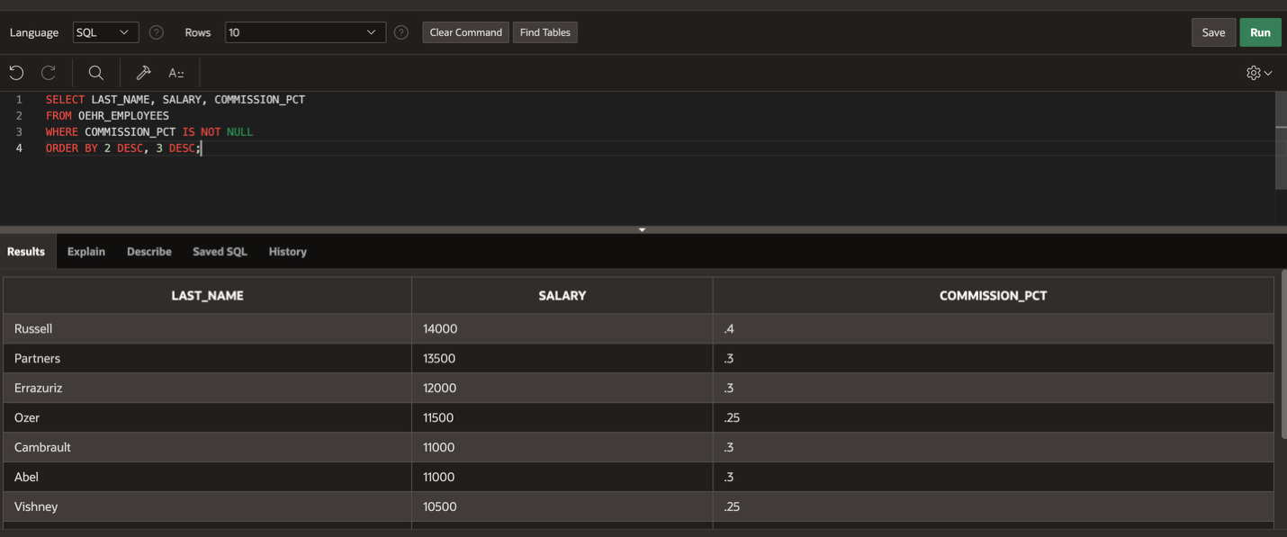
Lab Task 7:
Write a SQL statement that prompts the user for a manager ID and retrieves the employee ID, last name, salary, and department for that manager’s employees. The query must also prompt the column based on which the resultant rows will be sorted in ascending order. Test the data with the following values:
- manager_id=103, sorted by last_name
- manager_id = 201, sorted by salary
- manager_id = 124, sorted by employee_id
Output:
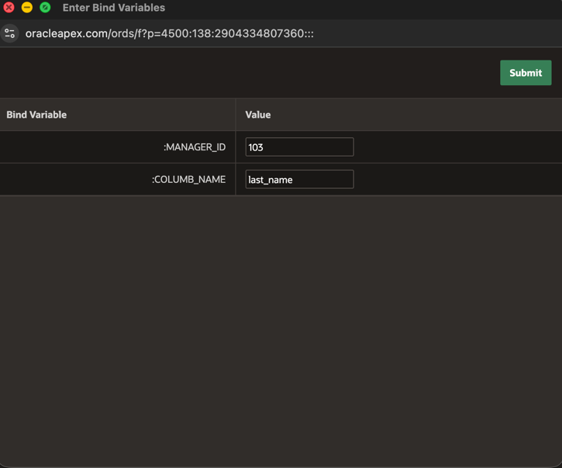
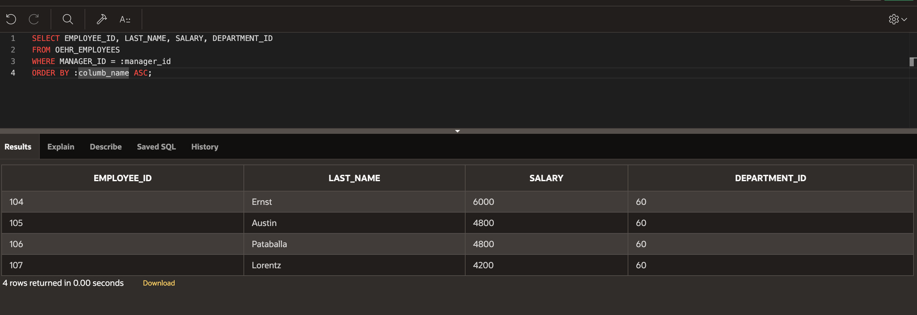
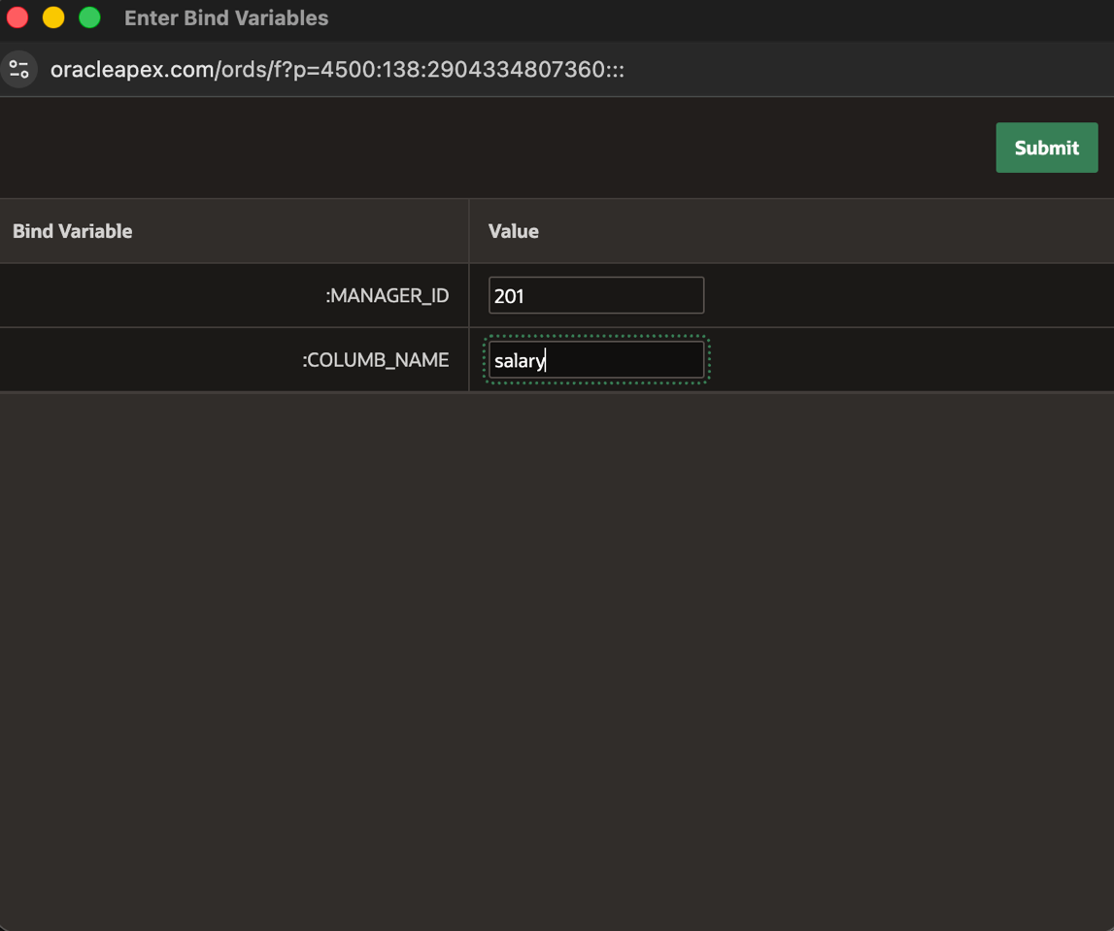
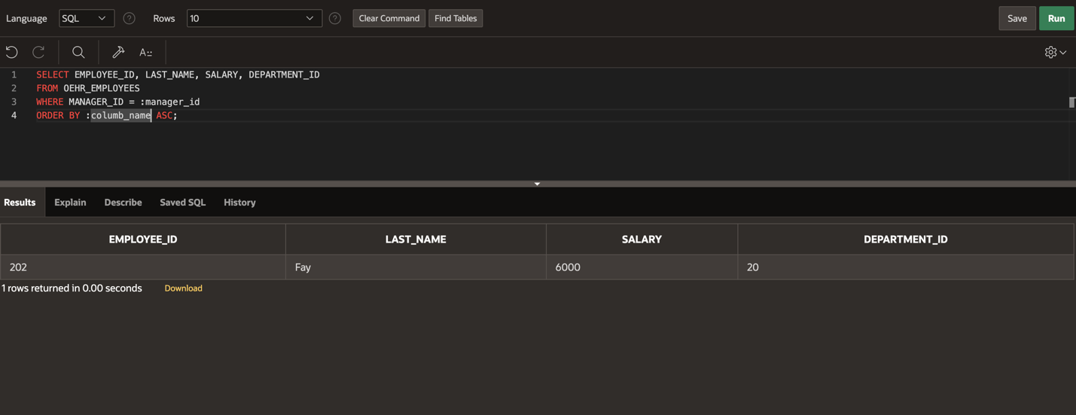
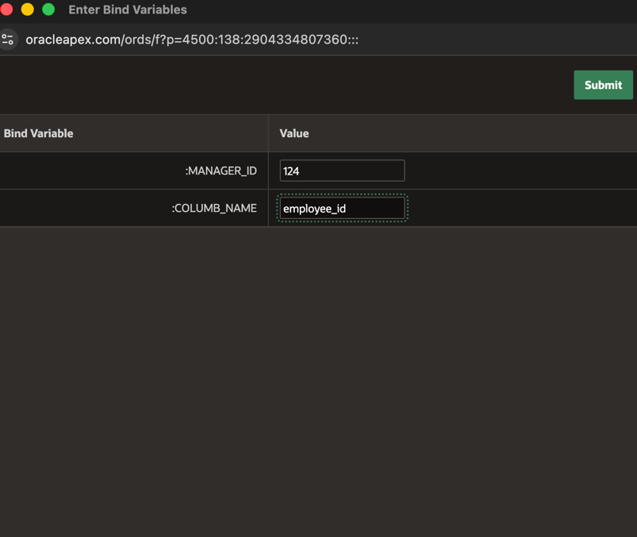
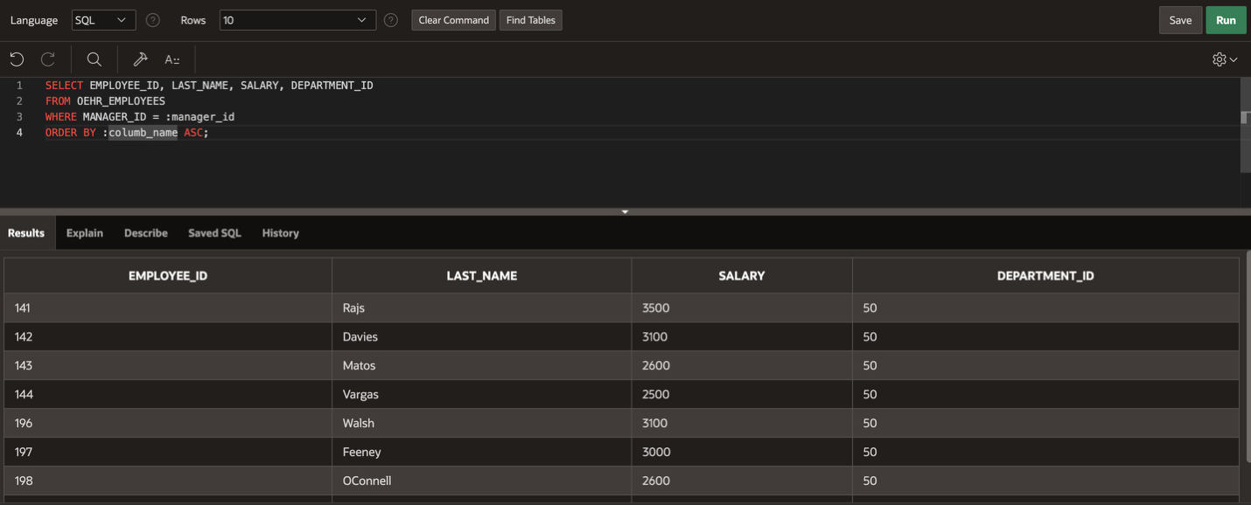
Lab Task 8:
Write a SQL statement that retrieves the last names of all employees who have both an “a” and an “e” somewhere in any order in their last name.
Output:
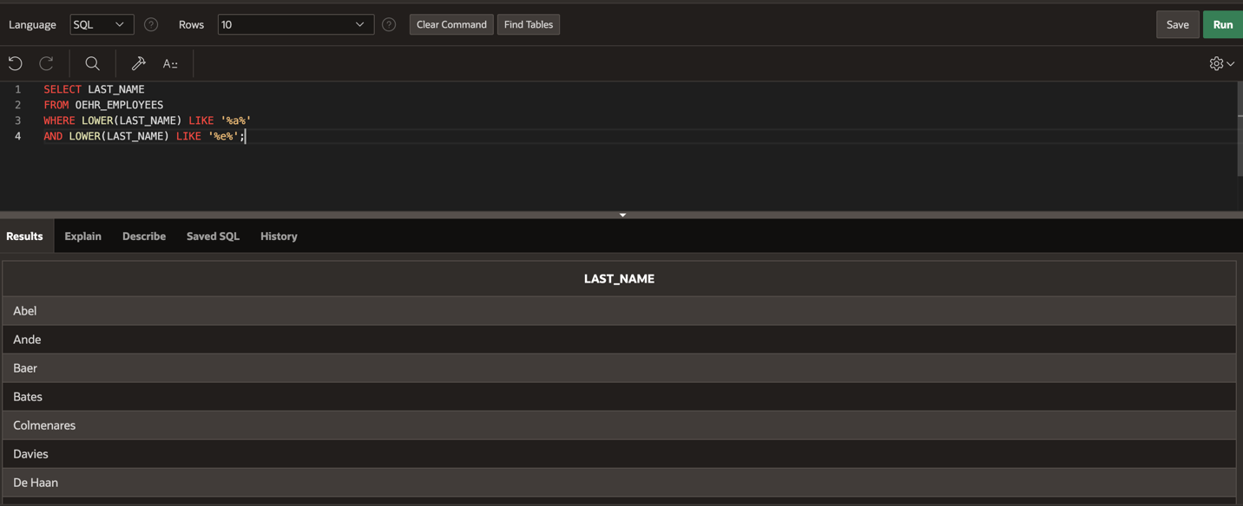
Lab Task 9:
Write a SQL statement that retrieves the last name, job, and salary for all employees whose jobs are either those of a sales representative or of a stock clerk, and whose salaries are not equal to 2500, 3500, or 7000.
Output:
